**Commodore PET IEEE-488 Extender Base Centronics Rev. 0**

**Testing**

# Setup

* CBM3016 computer
* CBM8032 computer
* CBM8050 floppy disk drive
* TFW8bit.com SD2PET future
* Standard Centronics IEEE-488 cable (1.5m)
* Centronics Base Rev. 0 with case
* Centronics Base Rev. 0 with Riser and jumper cable cable (drawing no. 169-3-02-00)

# Test execution

The Centronics Base was installed in the PET’s IEEE-488 port and a cable was attached.

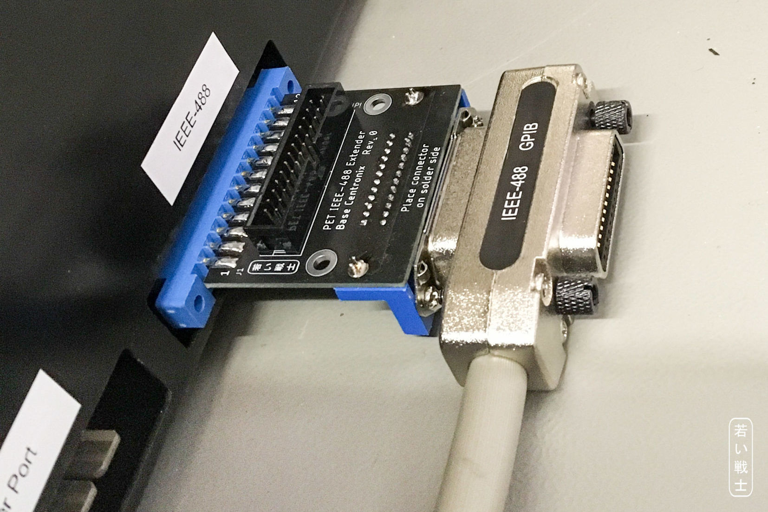

Figure 1: Installed Centronics Base with cable

The cable could be installed and was sitting firmly enough. There are no known screw posts for the connector (J3) to fit with the screws of the cable.

Then, a CBM8050 floppy disk drive was connected. Both, the computer and the drive were switched on. The drive can be flawlessly accessed.

A test fit was performed with SD2PET future, the CBM8050 (device address 9) with cable and a user port WiFi modem (Figure 3). The configuration did not interfere mechanically. The SD2PET future could be accessed as could the CBM8050. It was possible to copy the content of several floppy disks to the SD2PET future without any problems.

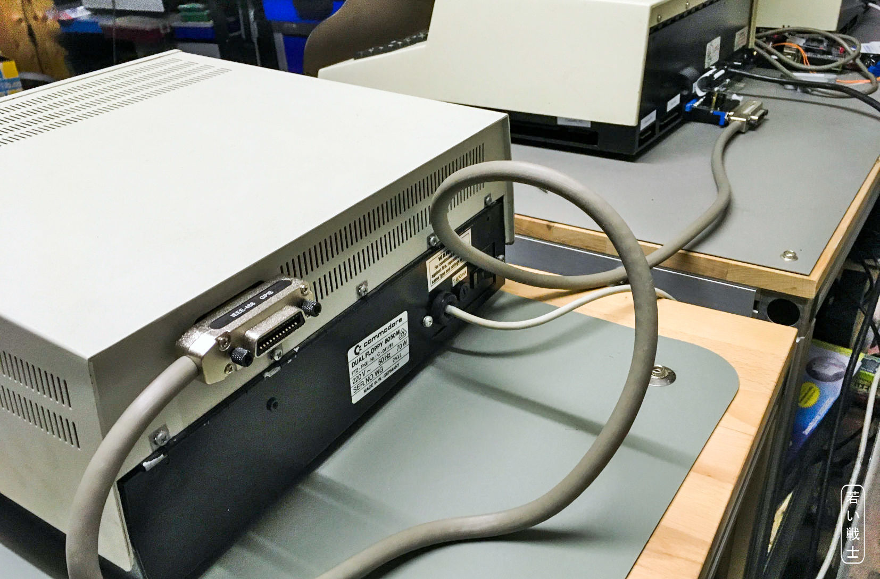

Figure 2: CBM8050 drive connected via cable and the Centronics Base rev. 0

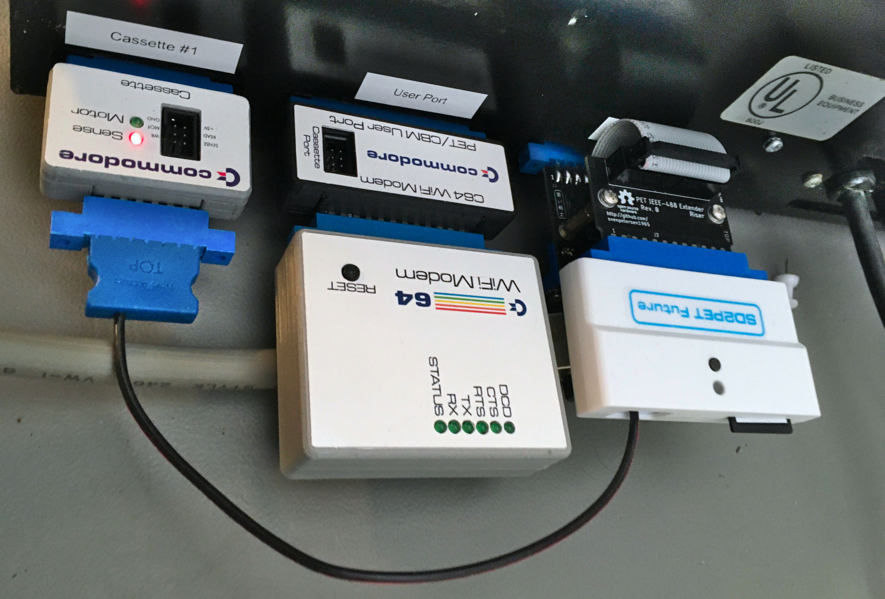

Figure 3: Centronics Base with Riser card, SD2PET future and user port peripherals (Wifi modem)

# Other Computers

The tests were repeated with the CBM3016 and the miniPET. No problems were noticed.

# Conclusion

The Centronics Base rev. 0 is working flawlessly.